Shell Script Assignment

Mandatory:

1. Create a script named “myscript” in current directory to do the following.

🡺To create a script named “myscript” in current directory use the “touch” command.

a) display “hello user”

🡺To display “Hello user” by running the myscript file using the “./myscript” command.

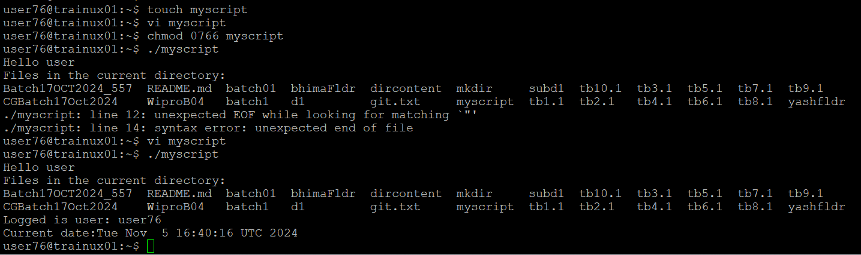

b) list files in current directory

🡺To list files in the directory using the command “ll”.

c) name of logged in user

🡺The name of logged in user, use this command “$whoami”

d) date

🡺To display the date using command “$date”.

2. Add execute permission and Run the script from

a) current directory

🡺To add execute permission use “chmod 0766 myscript” and run the script use ./myscript.

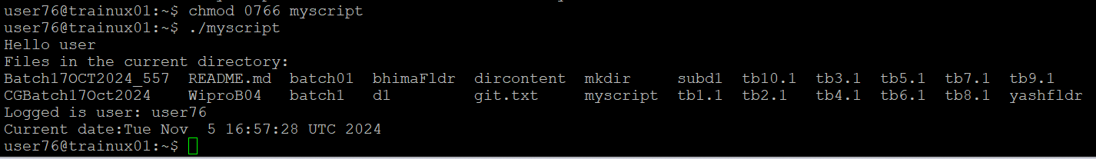

3. Create a subdirectory named “test”

🡺To create a subdirectory names test “mkdir test” is used.

4. Change to “test” directory. Run the script “myscript” [Hint: You will have to update PATH to include the directory containg script to run script from any location].

🡺To change to test directory and execute the myscript the commands used are:

>>cd test

>>export PATH=$PATH:$ (pwd)/..

>>myscript.sh

